Project Design Phase-II
Technology Stack (Architecture & Stack)
Date | 5 july 2026
Team ID | SWTID-2026-5158
Project Name | Indian agriculture crop analysis
Maximum Marks | 4 Marks

Technical Architecture:
The Deliverable shall include the architectural diagram as below and the information as per the table1 & table 2 Example: Order processing during pandemics for offline mode
Reference: https://developer.ibm.com/patterns/ai-powered-backend-system-for-order-processing-during-pandemics/
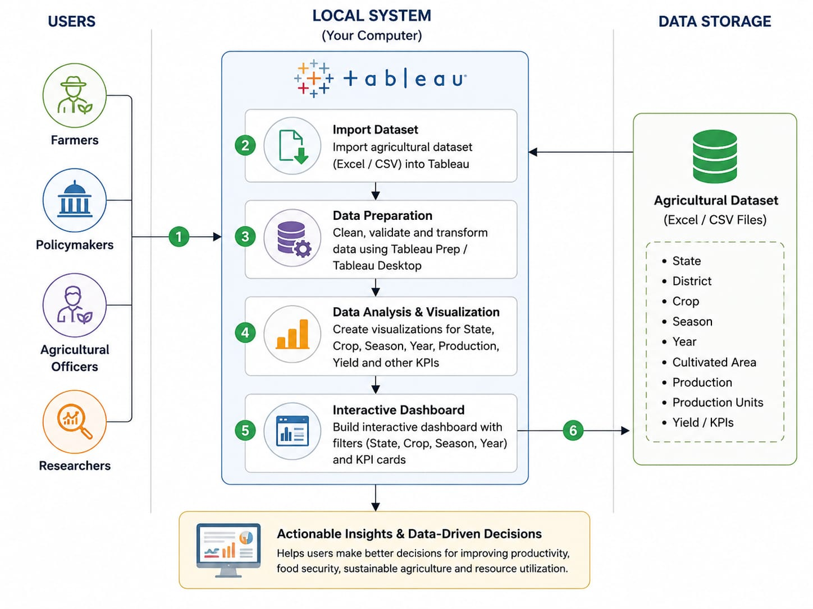
S.No | Component | Description | Technology
1. | User Interface | Interactive dashboard for agricultural data analysis . | Tableau Dashboard

2. | Application Logic-1 | Data preparation and transformation | Tableau Prep / Tableau Desktop
3. | Application Logic-2 | Data visualization and dashboard creation | Tableau Desktop
4. | Application Logic-3 | Interactive filters, KPIs and charts | Tableau Calculated Fields & Dashboard Actions
5. | Database | Agricultural dataset storage | Excel (.xlsx/.csv)
6. | Cloud Database | Not used | N/A .
7. | File Storage | Store dataset and Tableau workbook | Local File System
8. | External API-1 | Not used | N/A
9. | External API-2 | Not used | N/A
10. | Machine Learning Model | Not used | N/A
11. | Infrastructure (Server / Cloud) | Local system used for Tableau development | Windows PC + Tableau Desktop

Table-2: Application Characteristics:
S.No | Characteristics | Description | Technology
1. | Open-Source Frameworks | Data processed using CSV/Excel datasets | CSV / Microsoft Excel
2. | Security Implementations | Local file access and Tableau workbook protection | Windows User Authentication
3. | Scalable Architecture | Dashboard can be extended with additional datasets like weather, market prices, district-wise analysis | Tableau Dashboard Architecture
4. | Availability | Dashboard is available on the local system and can be published to Tableau Public if required | Tableau Desktop / Tableau Public

S.No | Characteristics | Description | Technology
5. | Performance | Optimized dashboard with filters, KPIs and interactive charts for fast analysis | Tableau Desktop

References:
https://c4model.com/
https://developer.ibm.com/patterns/online-order-processing-system-during-pandemic/
https://www.ibm.com/cloud/architecture
https://aws.amazon.com/architecture
https://medium.com/the-internal-startup/how-to-draw-useful-technical-architecture-diagrams-2d20c9fda90d

